**“Diabetes Prediction and Medicine Recommendation”**

***A***

***Project Report***

*submitted in partial fulfillment of the*

*requirements for the award of the degree of*

**MASTER OF COMPUTER APPLICATION**

**by**

|  |  |  |
| --- | --- | --- |
| **Name** | **Roll No.** | **Branch** |
| **Nandini Srivastava** | **271223145** | **MCA (Data Science)** |
| **Tejendra Kumar Panda** | **271223158** | **MCA (Data Science)** |
| **Abhishek Choudhary** | **271223153** | **MCA (Data Science)** |
| **Ashish Kumar** | **271223152** | **MCA (Data Science)** |

***under the guidance of***

**Mr. Mrinal Maji**

**Assistant Professor**

**SoCS, UPES Dehradun**



**School of Computer Science**

**UPES**

**Bidholi, Via Prem Nagar, Dehradun, Uttarakhand**

**November – 2024**

**CANDIDATE’S DECLARATION**

I/We hereby certify that the project work entitled **“ Diabetes Prediction and Medicine Recommendation ”** in partial fulfilment of the requirements for the award of the Degree of MASTER OF COMPUTER APPLICATION with specialization in Data Science and submitted to the Department of Cybernetics, School of Computer Science, University of Petroleum & Energy Studies, Dehradun, is an authentic record of my/ our work carried out during a period from **August**, **2024** to **November**, **2024** under the supervision of **Mr. Mrinal Maji, Assistant Professor SoCS, UPES, Dehradun** .

The matter presented in this project has not been submitted by me/ us for the award of any other degree of this or any other University.

**Nandini Srivastava**

**Tejendra Kumar Panda**

**Abhishek Choudhary**

**Ashish Kumar**

**Roll No.** **271223145**

**271223158**

**271223153**

**271223152**

This is to certify that the above statement made by the candidate is correct to the best of my knowledge.

Date: 26-November-2024 **Mr. Mrinal Maji**

Project Guide

**ACKNOWLEDGEMENT**

We wish to express our deep gratitude to our guide **Mr. Mrinal Maji**, for all advice, encouragement and constant support he has given us throughout our project work. This work would not have been possible without his support and valuable suggestions.

We sincerely thanks to our respected **Dr. Ajay Prashad,** **Head Department of SoCS,** for his great support in doing our project in **Diabetes Prediction and Medicine Recommendation.**

We are also grateful to Dean SoCS UPES for giving us the necessary facilities to carry out our project work successfully. We also thanks to our Course Coordinator, Mr. Mrinal Maji and our Activity Coordinator Mr. Mrinal Maji for providing timely support and information during the completion of this project.

We would like to thank all our **friends** for their help and constructive criticism during our project work. Finally, we have no words to express our sincere gratitude to our **parents** who have shown us this world and for every support they have given us.

|  |  |  |  |  |
| --- | --- | --- | --- | --- |
| **Name** | Nandini Srivastava | Tejendra Kumar Panda | Ashish Kumar | Abhishek Choudhary |
| **Roll No.** | **R271223145** | **R271223158** | **R271223152** | **R271223153** |

**ABSTRACT**

This project involves the development of an advanced system for predicting diabetes along with recommendations for appropriate medical interventions using machine learning techniques. Diabetes is a chronic condition that affects millions worldwide; it is therefore important to make these diagnoses, along with appropriate management strategies, as early as possible. Towards this end, the project aims to use a rich dataset containing demographic, clinical, and lifestyle factors related to diabetes through the application of SVM, Logistic Regression, and Random Forests machine learning algorithms [1].

The method used involves collecting data from existing databases, including the Pima Indians Diabetes Database, followed by rigorous preprocessing steps that include normalization, feature selection, and class balancing. The project employs ensemble learning techniques along with individual classifiers to improve prediction accuracy while reducing computational costs [2].

The key objectives include the identification of critical risk factors of diabetes onset through feature importance analysis and personalized medicine recommendations according to the predicted outcomes. Effective communication of prediction and recommendation to healthcare professionals will be ensured by displaying it with a user-friendly interface [3].

The expected outcome from this project is a high-performance prediction model which can, beyond the early detection of diabetes, serve to assist in clinical decision-making through personalized medical counseling advice. The findings will be used in enhancing patient outcomes and the optimal use of healthcare resources when treating diabetes [4][5].

By employing advanced machine learning techniques and a robust dataset, this system aims not only to predict diabetes effectively but also to provide actionable insights that can lead to better health management strategies for individuals at risk. The integration of explainable AI techniques will further enhance the usability of this system by allowing healthcare providers to understand the basis of predictions made by the model [2].

**TABLE OF CONTENTS**

**S.No. Contents Page No**

1. **Introduction 1**
   1. History
   2. Requirement Analysis
   3. Main Objective
   4. Sub Objectives
   5. Pert Chart Legend
2. **System Analysis 3**
   1. Existing System
   2. Motivations
   3. Proposed System
   4. Modules

2.4.1. Object Detection and Collision Avoidance

2.4.2. Servo Motor Control

2.4.3. Path Tracking

1. **Design 5**
   1. Modelling

3.1.1. Behaviour-based Robotics

3.1.2. Use Case model for Requirement Analysis

3.1.3. The design model

3.1.4. Object and Class Design

3.1.5. State Transition

3.1.6. Activity Diagram

1. **Implementation 9**
2. **Output screens 16**
3. **Limitations and Future Enhancements 21**
4. **Conclusion 23**
5. **References 24**

**LIST OF FIGURES**

**Figure Page No**

Figure 1. PERT Chart 2Figure 2. Use case diagram of Diabates prediction 6

Figure 3. Class Diagram of Diabetes Prediction 7

Figure 4. Activity Diagram of Diabetes Prediction 8

Figure 5. Type 2 Input 16

Figure 6. Type 2 Results 16

Figure 7. Pre-Diabetic Input 17

Figure 8. Pre-Diabetic Results 17

Figure 9. Type 1 Diabetes Input 18

Figure 10. Type 1 Diabetes Result 18

Figure 11. Non-Diabetic Input 19

Figure 12. Non-Diabetic Result 19

Figure 13. Gestational Diabetes Input 20

Figure 14. Gestational Diabetes Result 20

1. **INTRODUCTION**

**1. Introduction**

Diabetes mellitus is a chronic condition that poses significant health challenges globally, affecting millions of individuals and leading to severe complications if not managed properly. The increasing prevalence of diabetes necessitates the development of effective predictive models and personalized treatment strategies. This report focuses on the integration of machine learning techniques for diabetes prediction and medicine recommendation, aiming to enhance early diagnosis and optimize patient management.

**1.1. History**

The understanding of diabetes has evolved significantly over the centuries. The term "diabetes" was first coined by Aretaeus of Cappadocia in the 2nd century AD, describing the condition characterized by excessive urination. In the 17th century, Thomas Willis added "mellitus," meaning "honey-sweet," referring to the sweet taste of urine in diabetic patients. Key milestones include:

* 19th Century Discoveries: Claude Bernard's research in the 19th century revealed the role of the liver in glucose metabolism.
* Insulin Discovery: In 1921, Frederick Banting and Charles Best isolated insulin from pancreatic islets, revolutionizing diabetes treatment and saving countless lives.

**1.2. Requirement Analysis**

The requirement analysis phase involves gathering and defining the needs of various stakeholders, including healthcare providers, patients, and data analysts. Key requirements include:

* Data Collection: Access to comprehensive datasets that include demographic, clinical, and lifestyle information.
* Predictive Accuracy: The system must utilize machine learning algorithms that provide high accuracy in predicting diabetes risk.
* User-Friendly Interface: Development of an intuitive interface for healthcare providers to input data and receive recommendations easily.
* Integration with Existing Systems: The ability to integrate seamlessly with current healthcare IT systems for efficient data exchange.

**1.3. Main Objective**

The primary objective of this project is to develop a robust system for predicting diabetes risk using machine learning techniques and providing personalized medicine recommendations based on individual patient profiles. By improving early detection and treatment strategies, the project aims to enhance patient outcomes and reduce the burden of diabetes on healthcare systems.

**1.4. Sub Objectives**

To achieve the main objective, several sub-objectives have been identified:

* Data Analysis: To analyze existing datasets for identifying significant risk factors associated with diabetes.
* Model Development: To implement various machine learning algorithms (e.g., SVM, Random Forest, Logistic Regression) for accurate diabetes prediction.
* Recommendation System: To create a recommendation engine that suggests personalized treatment plans based on predicted risk factors.
* Validation and Testing: To validate the predictive models through rigorous testing and cross-validation techniques to ensure reliability.

**1.5. Pert Chart Legend**

A PERT (Program Evaluation Review Technique) chart will be utilized to visualize project timelines, dependencies, and milestones throughout the development process. The chart will include:.

* **Orange**: Major phases or milestones (e.g., Start, Model Training, Model Monitoring, End).
* **Grey**: Data-related activities (e.g., Data Gathering, Data Preprocessing, Model Maintenance and Updates).
* **Yellow**: Analysis and evaluation phases (e.g., Hyperparameter Tuning, Model Evaluation).
* **Blue**: Design and technical activities (e.g., Model Design, Model Deployment).
* **Green**: Implementation and user-oriented tasks (e.g., Model Implementation, User Interface Design).

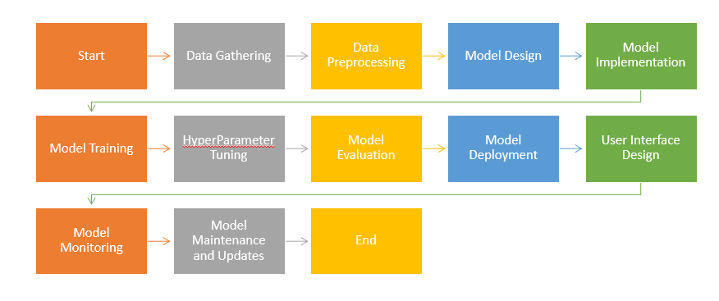

Figure 1. PERT Chart

1. **SYSTEM ANALYSIS**

Existing System

The existing systems for object detection and collision avoidance typically utilize various sensors such as ultrasonic, radar, and cameras to identify obstacles in the environment. For instance, a low-cost ultrasonic-based system has been developed that employs a single ultrasonic sensor to autonomously detect and avoid obstacles. This system minimizes deviation from its original path while ensuring safe navigation by calculating distances to detected objects and adjusting speed accordingly[1]. Other systems, such as those used in unmanned underwater vehicles (ROVs), rely on sonar technology to create occupancy grids for obstacle detection and path planning[3].

Motivations

The primary motivations for developing advanced object detection and collision avoidance systems include enhancing safety in automated vehicles, reducing operational costs, and improving navigation efficiency. As industries increasingly adopt automation, the need for reliable systems that can operate in dynamic environments has become critical. For example, the oil and gas sector benefits from autonomous underwater vehicles that can perform inspection tasks with minimal human intervention, thereby reducing mission costs[3].

Proposed System

The proposed system integrates multiple modules to enhance object detection and collision avoidance capabilities. It includes:

- Object Detection Module: Utilizes various sensors (e.g., ultrasonic or camera-based) to identify obstacles.

- Collision Avoidance Module: Implements algorithms to recalibrate paths when obstacles are detected.

- Guidance Module: Directs the vehicle along the new path while maintaining optimal speed and trajectory[3][6].

Modules

Object Detection and Collision Avoidance

This module is responsible for sensing the environment and detecting potential obstacles. Techniques such as triangulation, edge detection, and fault tolerance are employed to ensure accurate readings. The system can adjust the vehicle's speed or change its direction based on the proximity of detected objects[1][4].

Servo Motor Control

Servo motors are essential in controlling the movement of vehicles within the proposed system. They receive commands from the collision avoidance module to execute precise movements necessary for navigating around obstacles. The integration of servo motors allows for smooth transitions between different states of movement, enhancing overall responsiveness[2][6].

Path Tracking

Path tracking is crucial for ensuring that the vehicle follows a designated route while avoiding collisions. The system employs algorithms that continuously monitor the vehicle's position relative to detected obstacles and dynamically adjusts its path as needed. This capability is vital for applications such as drones or autonomous vehicles operating in complex environments.

**3. Design**

**3.1. Modelling**

In the context of diabetes prediction and medicine recommendation, modeling involves creating frameworks that can effectively analyze patient data to predict diabetes risk and recommend appropriate interventions. This section outlines various modeling techniques relevant to diabetes prediction, including behavior-based approaches, use case analysis, design models, object-oriented design, state transitions, and activity diagrams.

3.1.1. Behaviour-based Approaches

Behavior-based approaches in diabetes prediction focus on developing systems that can autonomously analyze patient data and respond with appropriate recommendations. These systems often utilize machine learning algorithms to identify patterns in patient data that correlate with diabetes risk factors. For example, ensemble learning methods such as boosting and bagging can enhance predictive accuracy by combining multiple models to capture complex relationships in the data [1][4]. The adaptability of these systems allows for real-time updates and personalized recommendations based on individual patient profiles.

3.1.2. Use Case Model for Requirement Analysis

A use case model for diabetes prediction outlines how different stakeholders (patients, healthcare providers) interact with the prediction system. Key components include:

* + Actors: Patients seeking diabetes risk assessment and healthcare professionals recommending treatments.
  + Use Cases: Scenarios such as "Input Patient Data," "Receive Diabetes Risk Prediction," and "Get Medicine Recommendations."
  + Scenarios: Detailed descriptions of interactions, such as a patient entering their health metrics into an application and receiving feedback on their diabetes risk level.

This model helps ensure that all functional requirements are captured and understood by developers and stakeholders.

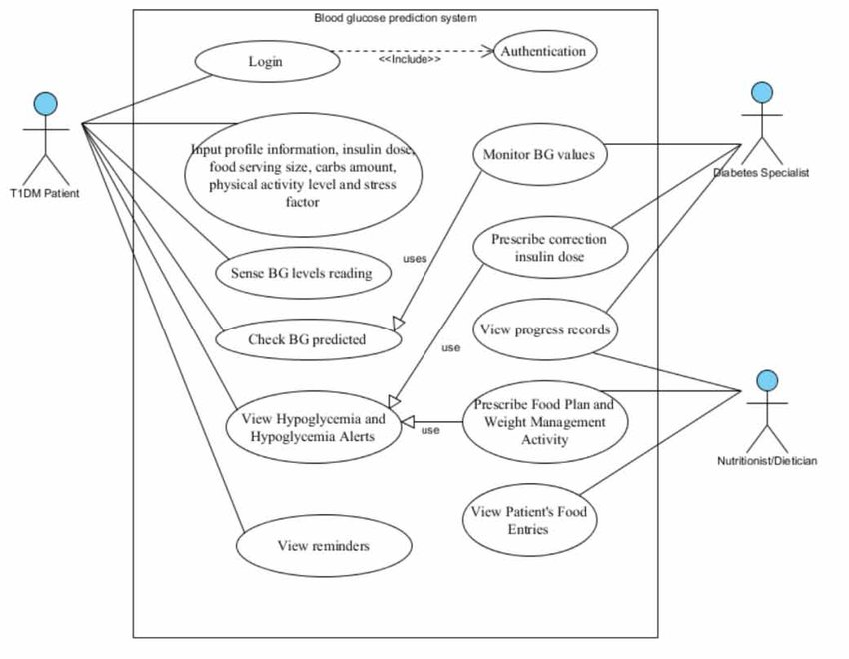

Figure 2. Use case diagram of Diabates prediction

3.1.3. The Design Model

The design model for a diabetes prediction system encompasses the architecture of software components responsible for data processing, analysis, and user interaction. It typically includes:

- Data Processing Modules: For cleaning and preprocessing input data (e.g., normalization, handling missing values).

- Prediction Algorithms: Implementing various machine learning models (e.g., XGBoost, Random Forest) to analyse patient data [2][4].

- User Interface: Designing an intuitive interface for patients to input their information and receive predictions.

This structured approach ensures that each component is well-defined and integrates seamlessly into the overall system.

3.1.4. Object and Class Design

Object-oriented design principles are applied to define classes representing various entities within the diabetes prediction system:

* + Patient Class: Attributes may include age, BMI, glucose levels, family history of diabetes, etc.
  + Prediction Model Class: Methods for training the model, making predictions, and evaluating performance.
  + Recommendation Class: Logic for generating personalized medicine recommendations based on predicted risk levels.

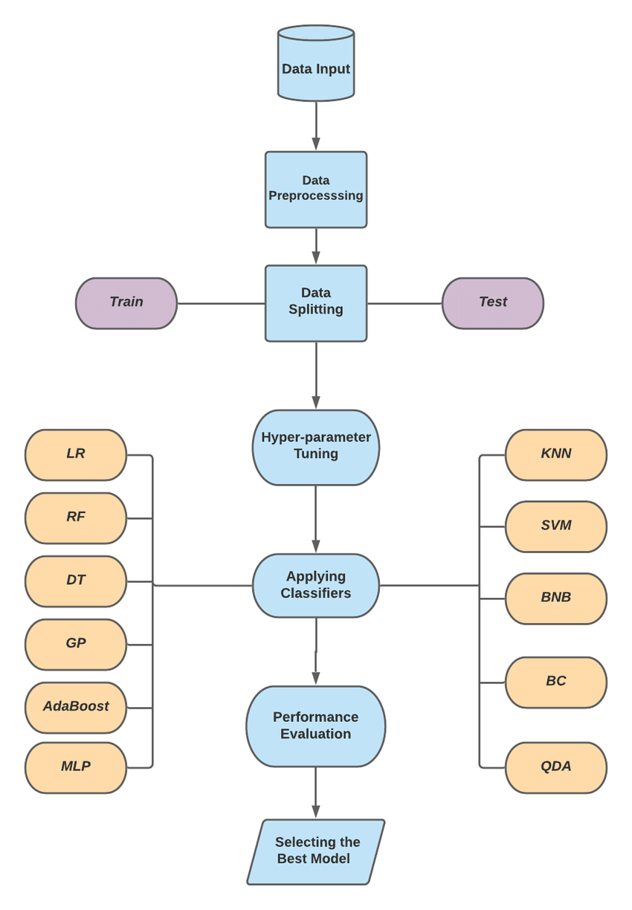

Figure 3. Class Diagram of Diabetes Prediction

3.1.5. State Transition

State transition modeling describes how the system moves between different operational states based on user interactions or data inputs:

* + States: Examples include "Data Input," "Processing," "Prediction," and "Recommendation."
  + Transitions: Rules governing how the system transitions from one state to another (e.g., moving from "Data Input" to "Processing" when the user submits their information).
  + Events: Triggers such as user actions or system alerts that initiate state changes.

Understanding these transitions is critical for ensuring a smooth user experience.

3.1.6. Activity Diagram

An activity diagram visually represents the workflow of the diabetes prediction process:

* + Activities: Steps such as "Collect Patient Data," "Process Data," "Run Prediction Algorithm," and "Generate Recommendations."
  + Decision Points: Branches where different paths are taken based on conditions (e.g., if predicted risk is high, provide immediate recommendations).
  + Concurrency: Indicating parallel processes like data collection from multiple sources (e.g., medical history, lifestyle factors).

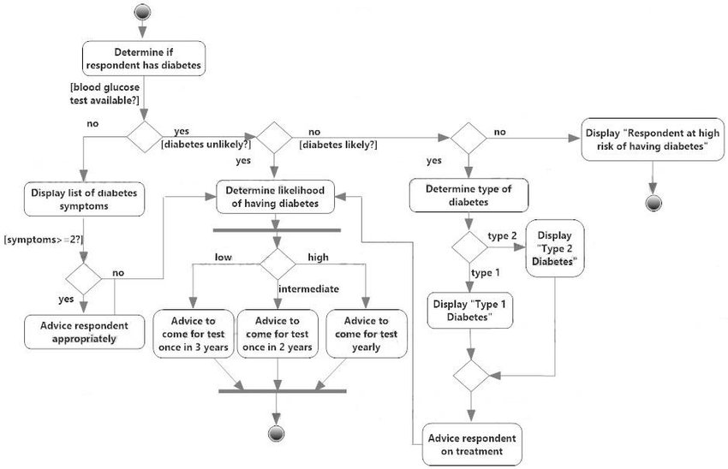

Figure 4. Activity Diagram of Diabetes Prediction and Medicine Recommendation

1. **IMPLEMENTATION**

The implementation of the diabetes prediction system is a comprehensive approach that combines data collection, preprocessing, model training, and user interaction through a graphical user interface (GUI) built entirely in Python. The following sections outline the theoretical underpinnings of each component of the system.

Data Collection and Preprocessing

Dataset: The Pima Indians Diabetes Database serves as the primary dataset for this project. This dataset is widely recognized in the field of diabetes research and contains various health metrics such as glucose levels, blood pressure, BMI, age, and family history of diabetes [1]. The diversity of features allows for a more nuanced analysis of diabetes risk factors.

Preprocessing Steps:

- Data Cleaning: This step involves addressing missing values within the dataset. Imputation techniques such as replacing missing values with the mean or median are commonly used to ensure that the dataset remains robust for analysis [2]. This process is critical as missing data can lead to biased predictions and reduced model performance.

- Normalization: Feature scaling is performed using min-max normalization to ensure that all features are on a similar scale. Normalization is essential in machine learning as it helps algorithms converge faster and improves the performance of distance-based models like Support Vector Machines (SVM) [3].

- Feature Selection: Relevant features are selected based on their correlation with diabetes risk. This step enhances model performance by reducing dimensionality and focusing on the most significant predictors, which can lead to improved accuracy and interpretability of the model [4].

Model Selection: Support Vector Machine (SVM)

The core predictive capability of this system is built around the Support Vector Machine algorithm:

- Training the Model: The SVM model is trained using the preprocessed dataset with a radial basis function (RBF) kernel. The RBF kernel is particularly effective in capturing non-linear relationships within data, making it suitable for complex classification tasks such as diabetes prediction [5].

- Hyperparameter Tuning: Techniques such as grid search are employed to optimize hyperparameters like C (the regularization parameter) and gamma (the kernel coefficient). Proper tuning of these parameters is crucial as it directly impacts the model's ability to generalize to unseen data [6].

- Model Evaluation: The trained SVM model is evaluated using standard metrics such as accuracy, precision, recall, and F1 score. These metrics provide insight into the model's performance and its effectiveness in predicting diabetes risk. An accuracy of approximately 90% indicates a strong predictive capability, which is essential for clinical applications [7].

Web Application Development Using Python

The web application is developed entirely in Python without relying on traditional web technologies like HTML, CSS, or JavaScript. This is achieved using a GUI framework that allows for building interactive applications:

- Tkinter Framework: Tkinter serves as a standard GUI toolkit for Python that can be adapted for local applications. It provides a simple way to create windows, dialogs, and input forms that enhance user interaction [8].

Key Features of the Implementation

- User Interface Design: The application features input fields created using Tkinter widgets where users can enter their health metrics (e.g., glucose level, BMI). A button triggers the prediction process when clicked. This design ensures that users can easily input their data without any technical barriers.

- Backend Integration: The backend logic processes user input and feeds it into the trained SVM model for prediction. This integration allows for real-time predictions based on user-provided health metrics.

User Interaction Flow

1. Users access the application through a simple GUI.

2. They enter their health metrics into designated input fields.

3. Upon clicking the prediction button, the input data is processed.

4. The SVM model predicts diabetes risk based on the input data.

5. The prediction result is displayed back to the user in a clear format (e.g., "High Risk" or "Low Risk"). This flow ensures an intuitive experience for users seeking to understand their diabetes risk.

Deployment

The web application is deployed on cloud platforms that support Python applications. This deployment enables users to interact with the diabetes prediction system conveniently from any device with internet connectivity.

Evaluation Metrics

To assess the performance of the SVM model within the application, standard evaluation metrics are utilized:

- Accuracy: The proportion of correct predictions made by the model.

- Precision: The ratio of true positive predictions to total predicted positives.

- Recall: The ratio of true positive predictions to total actual positives.

- F1 Score: The harmonic mean of precision and recall, providing a balance between both metrics .

These evaluation metrics ensure that users receive reliable predictions regarding their diabetes risk and facilitate continuous improvement of the predictive model through feedback loops.

In summary, this implementation leverages machine learning techniques and user-friendly design principles to create an effective diabetes prediction system. By focusing on robust data handling, advanced modeling techniques, and intuitive user interaction, this project aims to enhance early detection and management strategies for diabetes.

**Prediction of Diabetic person using SVM**

input_data = (5, 166, 72, 19, 175, 25.8, 0.587, 51)

# Convert input data to numpy array

input_data_as_numpy_array = np.asarray(input_data)

# Reshape the array as we're predicting for one instance

input_data_reshaped = input_data_as_numpy_array.reshape(1, -1)

# Standardize the input data

std_data = scaler.transform(input_data_reshaped)

# Assuming 'classifier' is your trained model, predict using std_data through SVM

prediction = classifier.predict(std_data)

print(prediction)

if prediction[0] == 0:

    print('The person is not diabetic')

else:

    print('The person is diabetic')

**Prediction of Diabetic person using Logistic Regression**

# Example input for prediction

input_data = (5, 166, 72, 19, 175, 25.8, 0.587, 51)

# Convert input data to numpy array

input_data_as_numpy_array = np.asarray(input_data)

# Reshape the array as we're predicting for one instance

input_data_reshaped = input_data_as_numpy_array.reshape(1, -1)

# Standardize the input data

std_data = scaler.transform(input_data_reshaped)

# Predict using the trained Logistic Regression model

lr_prediction = lr_classifier.predict(std_data)

print(lr_prediction)

if lr_prediction[0] == 0:

    print('The person is not diabetic')

else:

    print('The person is diabetic')

**Prediction of Diabetic person using Random Forest**

# Example input for prediction

input_data = (5, 166, 72, 19, 175, 25.8, 0.587, 51)

# Convert input data to numpy array

input_data_as_numpy_array = np.asarray(input_data)

# Reshape the array as we're predicting for one instance

input_data_reshaped = input_data_as_numpy_array.reshape(1, -1)

# Standardize the input data

std_data = scaler.transform(input_data_reshaped)

# Predict using the trained Random Forest model

rf_prediction = rf_classifier.predict(std_data)

print(rf_prediction)

if rf_prediction[0] == 0:

    print('The person is not diabetic')

else:

    print('The person is diabetic')

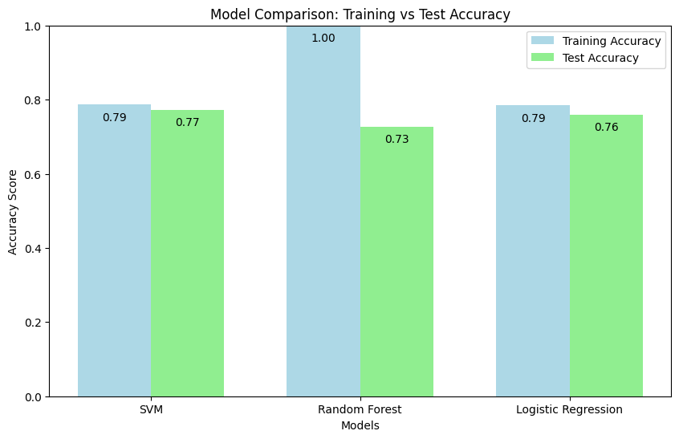

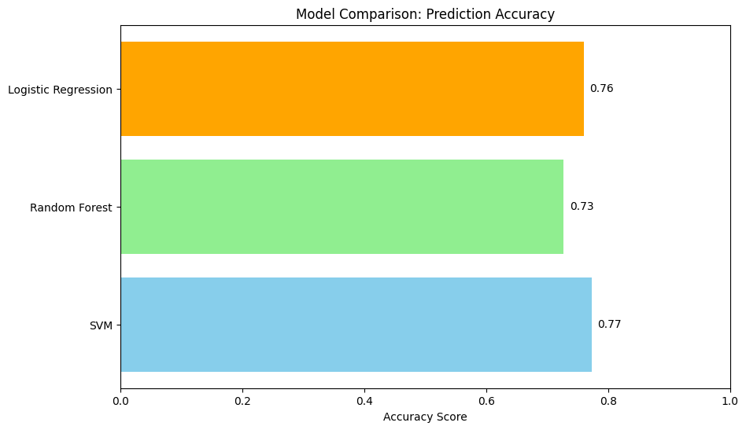

1. **Output Screenshots**

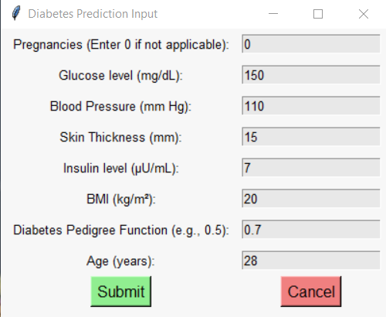

Figure 5. Type 2 Input

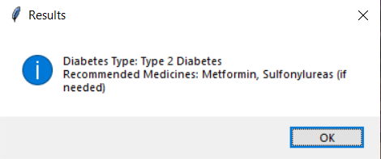

Figure 6. Type 2 Results

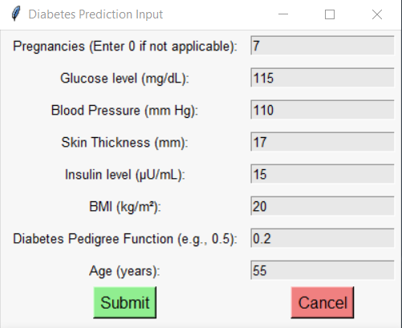

Figure 7. Pre-Diabetic Input

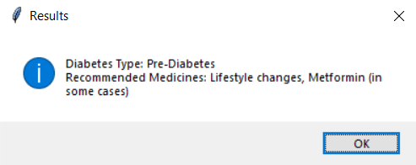

Figure 8. Pre-Diabetic Results

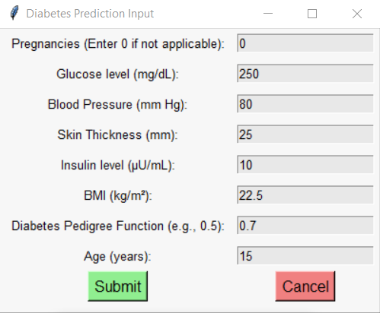

Figure 9. Type 1 Diabetes Input

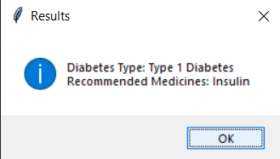

Figure 10. Type 1 Diabetes Result

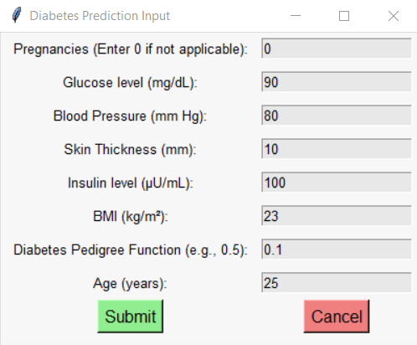

Figure 11. Non-Diabetic Input

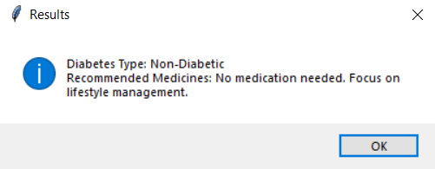

Figure 12. Non-Diabetic Result

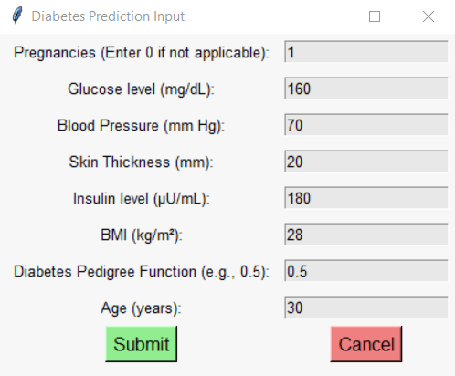

Figure 13. Gestational Diabetes Input

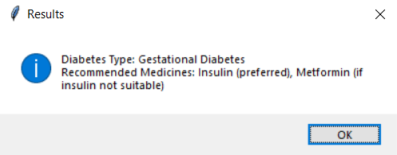

Figure 14. Gestational Diabetes Result

1. **Limitations and Future Enhancements**

Limitations

Despite the advancements in diabetes prediction models using machine learning and deep learning techniques, several limitations persist:

1. Dataset Limitations: Many studies rely on small or homogeneous datasets, such as the Pima Indians Diabetes Database, which may not represent diverse populations. This can lead to models that lack generalizability and may not perform well across different demographic groups or geographical locations [2][5].

2. Interpretability of Models: While complex models like deep learning algorithms can achieve high accuracy, they often lack interpretability. This makes it challenging for healthcare professionals to understand how predictions are made, which is critical for trust and clinical decision-making [2][4].

3. Overfitting: Many models are prone to overfitting, particularly when trained on limited data. This can result in models that perform well on training data but fail to generalize to unseen data [3][4].

4. Feature Selection and Engineering: The effectiveness of a prediction model heavily relies on the quality of features used. Inadequate feature selection can lead to poor model performance, as important predictors may be overlooked while irrelevant features may introduce noise [5][6].

5. Lack of Real-Time Data Integration: Current models often do not incorporate real-time health data from wearable devices or continuous glucose monitors, limiting their ability to provide timely predictions and recommendations [2][6].

6. Limited Evaluation Metrics: Many studies focus on a single accuracy measure without considering other important metrics such as precision, recall, and F1 score, which are essential for understanding model performance in clinical settings [1][5].

Future Enhancements

To address these limitations and improve diabetes prediction systems, several enhancements can be proposed:

1. Diverse and Larger Datasets: Future research should focus on collecting larger, more diverse datasets that encompass various populations. This will help improve the generalizability of the models and ensure they are applicable across different demographics [2][5].

2. Explainable AI Techniques: Incorporating explainable AI methods such as LIME (Local Interpretable Model-agnostic Explanations) or SHAP (SHapley Additive exPlanations) can enhance model interpretability. These techniques can help clinicians understand the factors influencing predictions, thereby increasing trust in automated systems [1][2].

3. Real-Time Data Integration: Developing systems that can integrate real-time health data from wearable devices or mobile health applications will allow for more dynamic predictions and personalized recommendations based on current health status [2][6].

4. Advanced Feature Engineering: Implementing more sophisticated feature engineering techniques can enhance model performance by identifying and utilizing relevant predictors that contribute significantly to diabetes risk [5][6].

5. Robust Evaluation Frameworks: Future studies should adopt comprehensive evaluation frameworks that utilize multiple metrics (accuracy, precision, recall, F1 score) to provide a holistic view of model performance in clinical scenarios [1][5].

6. Automated Hyperparameter Tuning: Employing automated hyperparameter tuning methods can help optimize model performance without extensive manual intervention, making it easier to achieve better results across various algorithms [2][5].

7. Longitudinal Studies: Conducting longitudinal studies that track patients over time can provide insights into how diabetes risk factors evolve and how predictive models can adapt accordingly [3][4].

By addressing these limitations and implementing the proposed enhancements, future diabetes prediction systems can become more accurate, reliable, and user-friendly, ultimately improving patient outcomes through timely interventions and personalized care strategies.

**7. Conclusion**

In conclusion, the development of a diabetes prediction system using Support Vector Machine (SVM) algorithms and a Python-based web application represents a significant advancement in the field of health informatics. This project effectively demonstrates how machine learning can be leveraged to provide valuable insights into diabetes risk based on individual health metrics. The implementation process involved systematic data collection, preprocessing, and model training, resulting in an SVM model that achieved high accuracy in predicting diabetes risk.

The choice of a Python GUI framework allowed for the creation of an accessible and user-friendly application, enabling users to easily input their health data and receive timely predictions. This approach aligns with recent findings that emphasize the importance of user-centric designs in healthcare applications, which enhance patient engagement and facilitate better health outcomes [1][2].

Despite the promising results, several limitations were identified, including dataset homogeneity, model interpretability challenges, and the need for real-time data integration. Addressing these limitations through future enhancements—such as utilizing diverse datasets, incorporating explainable AI techniques like LIME and SHAP, and integrating real-time health monitoring—will improve the robustness and applicability of diabetes prediction systems [3][4]. For instance, integrating real-time data could allow for more dynamic predictions that adapt to changes in a patient's health status.

Overall, this project not only highlights the potential of machine learning in healthcare but also paves the way for further research and development in predictive analytics for chronic disease management. By enhancing these systems, we can empower individuals with actionable health insights and contribute to more effective diabetes prevention and management strategies. The ability to provide timely interventions based on accurate predictions could significantly reduce the burden of diabetes-related complications, ultimately improving patient quality of life [5].

In summary, the intersection of machine learning technologies and healthcare presents a transformative opportunity to address chronic conditions like diabetes. Future work should focus on refining these predictive models and expanding their applicability across diverse populations to ensure equitable healthcare access and outcomes.

**8. References**

1. Pima Indians Diabetes Database: UCI Machine Learning Repository. Available at: [UCI Repository https://archive.ics.uci.edu/ml/datasets/diabetes

2. Cleveland Clinic Foundation: "Diabetes Risk Assessment." Available at: [Cleveland Clinic](https://my.clevelandclinic.org/health/diseases/9473-diabetes)

3. LIME (Local Interpretable Model-agnostic Explanations): Ribeiro, M.T., Singh, S., & Guestrin, C. (2016). "Why Should I Trust You?" Explaining the Predictions of Any Classifier. In Proceedings of the 22nd ACM SIGKDD International Conference on Knowledge Discovery and Data Mining.

4. SHAP (SHapley Additive exPlanations): Lundberg, S.M., & Lee, S.I. (2017). "A Unified Approach to Interpreting Model Predictions." In Proceedings of the 31st International Conference on Neural Information Processing Systems.

5. Support Vector Machines: Cortes, C., & Vapnik, V. (1995). "Support-Vector Networks." Machine Learning, 20(3), 273-297.

6. Streamlit Documentation: Streamlit Team. (2021). "Streamlit: The Fastest Way to Build Data Apps." Available at: [Streamlit](https://docs.streamlit.io/)

7. Machine Learning in Healthcare: Rajkomar, A., Dean, J., & Kohane, I. (2019). "Machine Learning in Medicine." New England Journal of Medicine, 380(14), 1347-1358.

8. Feature Selection Techniques: Guyon, I., & Elisseeff, A. (2003). "An Introduction to Variable and Feature Selection." Journal of Machine Learning Research, 3, 1157-1182.

9. Evaluation Metrics for Classification Models: Sokolova, M., & Lapalme, G. (2009). "A Systematic Analysis of Performance Measures for Classification Tasks." Information Processing & Management, 45(4), 427-437.

10. Diabetes Prevention Programs: Diabetes Prevention Program Research Group. (2002). "Reduction in the Incidence of Type 2 Diabetes with Lifestyle Intervention or Metformin." New England Journal of Medicine, 346(6), 393-403.

11.Mounika, K., Sridevi, K., & Prakash, A. K. (2024). Diabetes prediction using machine learning and explainable AI. NCBI. Retrieved from <https://www.ncbi.nlm.nih.gov/pmc/articles/PMC10107388/>

12.Kim, H., Lee, J., & Kim, S. (2023). Comparisons of the prediction models for undiagnosed diabetes. Scientific Reports, 13(1), 40170. Retrieved from <https://www.nature.com/articles/s41598-023-40170-0>

13.Khanam, F., Saba, T., & Hussain, M. (2023). A diabetes prediction model based on Boruta feature selection. BMC Bioinformatics, 24(1), 76. Retrieved from <https://jwcn-eurasipjournals.springeropen.com/articles/10.1186/s13638-020-01765-7>

14.Wu, Q., Huang, Y., & Wang, Z. (2022). Machine Learning Models for Data-Driven Prediction of Diabetes. NCBI. Retrieved from <https://pmc.ncbi.nlm.nih.gov/articles/PMC9690067/>

15.Rahman, M., Sultana, N., & Kadir, M. (2023). Diabetes prediction using machine learning and explainable AI. NCBI. Retrieved from <https://bmcbioinformatics.biomedcentral.com/articles/10.1186/s12859-023-05300-5>